Introduction to Lab Equipment

Rosalyn Chan

York University

PHYS4061

Cody Storry

4th October 2021

**Introduction**

The aim of this experiment is to helped familiarize the use of the new equipment whereby components inside the external cavity diode laser are inspected and identified, followed by understanding the use and importance of the faraday isolator, the half wave plate and the beam splitting cube and finally relating the power of the laser to the number of photons given by the equation $I_{PD}=PR(λ)$ and $V_{PD}=I_{PD}R_{Load}=PR(λ)R_{Load}$ where data analysis would be carry out on three data sets of the half wave plate angle versus the photodetector value for the multimeter and the oscilloscope.

**Results:**

**Section 1.3.1: Getting to know the lab equipment**

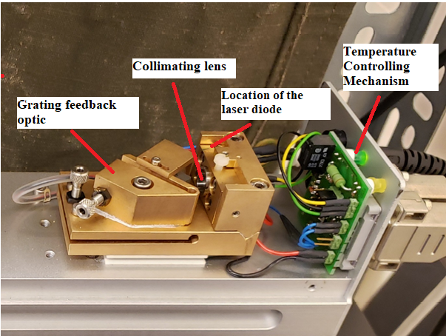

Figure 1: Components inside the ECDL

Figure 1 shows the component inside the external cavity diode laser where the collimating lens, grating feedback optic, location of the laser diode and temperature controlling mechanism are identified. The location of the laser diode is in the box with the lens while the temperature controlling mechanism is the green light control.

**Section 1.3.3: The Faraday Isolator**

The orientation of the linear polarizer at the input of the faraday isolator would be 0º while the orientation at the output would be 45º. When light gets reflected back to the output port of the isolator with an unchanged polarization state, it would fully transmit the output polarizer. Therefore, any reflected light back toward the laser would be linearly polarized at 45º and rotated by another additional 45º in the faraday isolator so that this light will be blocked at the input polarizer just before the laser or it could be sent to a separate output port.

**Section 1.3.4: The half-wave plate and beam splitter**

An important property of optical waves is their state of polarization. Linearly polarized light is produced once unpolarized light is passed through a polarizing medium whose axis is in line with the desired linear polarization. The polarized light that would be passing through a second polarizer allows only components that are parallel to the polarizing axis to emerge while the orthogonal component gets absorbed. One useful tool for manipulating polarized laser is the waveplate. The half-wave plate functions as a polarization rotator for linearly polarized laser whereby the half wave plate would be able to rotate the polarization of linearly polarized laser to twice the angle between its optic axis and initial polarization.

The combination of a linearly polarized laser through the half wave plate with the polarizing beam splitter generates a variable beam splitter. Rotation of the half wave plate to an arbitrary direction which then passes through the polarizing beam splitter splits a polarized laser beam into two parts. The polarization of light through the beam splitter governs the amount of laser the beam splitter transmits and reflect. Rotating the half wave plate to 45º with the input polarization provides total transmission through the beam splitter.

**Section1.3.5: Laser Detection**

Three data set of half-wave plate vs photodetector values and the number of photons are recorded with a multimeter, an oscilloscope and both the multimeter and the oscilloscope devices attached at the same time.

The lowest reading obtained on the multimeter is (12.26 ± 0.005)V at an angle of (208 ± 1)º.

From equation (1.1) and (1.2),

$$I_{PD}=PR(λ)$$

$$V_{PD}=I_{PD}R_{Load}=PR(λ)R_{Load}$$

We know,

$$P=nE$$

Where n is the number of photons per seconds and E is the energy with the given formula

$$E=\frac{hc}{λ}=\frac{\left(6.626×{10}^{-34}Js\right)\left(3×{10}^{8}\right)m}{s^{2}\left(780×{10}^{-9}\right)m}=2.548×{10}^{-19}/s$$

Therefore,

$$V_{PD}=\left(nE\right)R\left(λ\right)R_{Load}$$

$$n=\frac{V_{PD}}{{(R}_{Load})(E)R\left(λ\right)}$$

This would give us n as the number of photons emitted per second where $R_{Load}$ would be the load resistance for the Tektronix 1102B-EDU oscilloscope and Mastech 8269 DMM of 1MΩ and 10MΩ respectively. The wavelength dependent frequency of the photodiode is taken to be 0.48 A/W for wavelength of 780nm from the graph provided below.

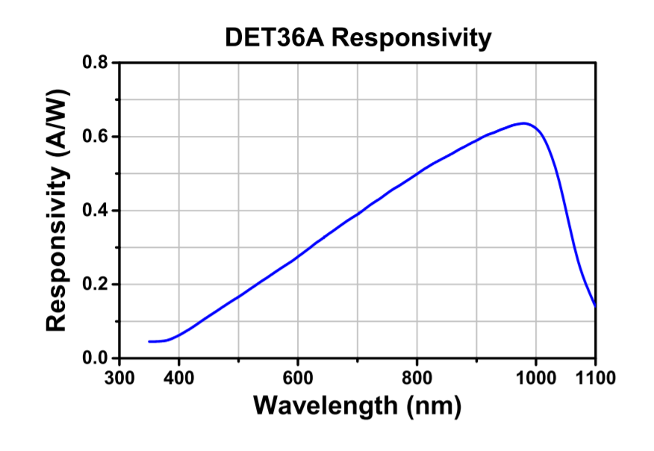

*DET36A(/M) Si Biased Detector, User Guide, 2017.June 30. THORLABS.* *https://wiki.nikhef.nl/gravwav/images/a/a9/DET36A-Manual.pdf*

Signal recorded by the multimeter due to the laser is (9.22± 0.005)V whereas signal due to background light is (9.22± 0.005)V. The result obtained from the fraction of the signal is found to be 99% of the laser.

$Fraction=\frac{9.14V}{9.22V}$ x 100% = 99%

**Data set 1:**

Recorded half wave plate angle and photodetector values with a digital multimeter of 10MΩ input impedance.

|  |  |  |
| --- | --- | --- |
| Half-wave plate angle, (±1º) | Photodetector value, (± 0.005 V) | No. of photons |
| 208 | 12.26 | 1.002× ${10}^{13}$ |
| 218 | 12.26 | 1.002× ${10}^{13}$ |
| 228 | 12.27 | 1.003× ${10}^{13}$ |
| 238 | 12.29 | 1.005× ${10}^{13}$ |
| 248 | 12.30 | 1.006× ${10}^{13}$ |
| 258 | 12.30 | 1.006× ${10}^{13}$ |
| 268 | 12.30 | 1.006× ${10}^{13}$ |
| 278 | 12.28 | 1.004× ${10}^{13}$ |
| 288 | 12.27 | 1.003× ${10}^{13}$ |
| 298 | 12.26 | 1.002× ${10}^{13}$ |
| 308 | 12.26 | 1.002× ${10}^{13}$ |
| 318 | 12.27 | 1.003× ${10}^{13}$ |

Table 1: Half wave plate angle and photodetector values with a digital multimeter.

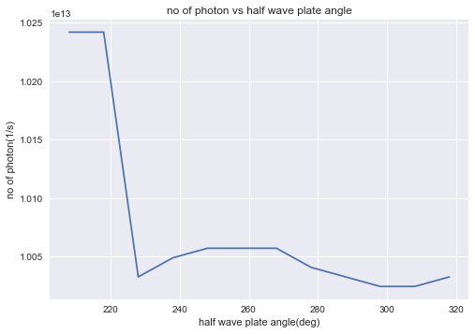

Figure 1: Plot of number of photons vs half wave plate angle for a multimeter.

**Data set 2:**

Recorded half wave plate angle and photodetector values with an oscilloscope of 1MΩ input impedance.

|  |  |  |
| --- | --- | --- |
| Half-wave plate angle, (±1º) | Voltage, (± 0.05 mV) | No. of photons |
| 308 | 10.1 | 8.258× ${10}^{10}$ |
| 318 | 10.5 | 8.585× ${10}^{10}$ |
| 328 | 12.3 | 1.006× ${10}^{11}$ |
| 338 | 13.2 | 1.079× ${10}^{11}$ |
| 348 | 13.9 | 1.137× ${10}^{11}$ |
| 358 | 13.3 | 1.087× ${10}^{11}$ |
| 8 | 11.5 | 9.403× ${10}^{10}$ |
| 18 | 10.8 | 8.830× ${10}^{10}$ |
| 28 | 10.2 | 8.340× ${10}^{10}$ |
| 38 | 10.6 | 8.667× ${10}^{10}$ |
| 48 | 11.5 | 9.403× ${10}^{10}$ |
| 58 | 12.6 | 1.030× ${10}^{11}$ |

Table 2**:** Half wave plate angle and photodetector values with an oscilloscope.

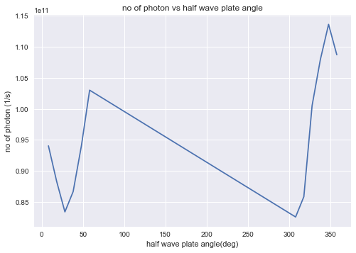

Figure 2: Plot of number of photon vs half wave plate angle with an oscilloscope

**Data set 3:**

Recorded half wave plate angle and photodetector values with an oscilloscope and digital multimeter connected at the same time of $\frac{10}{ 11}MΩ$ input impedance.

When both of the two devices are connected, the two internal resistances to the ground are in parallel.

$$\frac{1}{R_{Load}}=\frac{1}{R_{oscilloscope}}+\frac{1}{R_{multimeter}}$$

$$\frac{1}{R_{Load}}= \frac{1}{10MΩ}+\frac{1}{1MΩ}=\frac{11}{10MΩ}$$

|  |  |  |  |  |
| --- | --- | --- | --- | --- |
| Half-plate angle (±1º) | Photodetector value | | No. of photons | |
| Multimeter (±0.005mV) | Oscilloscope (±0.05mV) | Multimeter | Oscilloscope |
| 58 | 4.1 | 12.6 | 3.688× ${10}^{10}$ | 1.133× ${10}^{11}$ |
| 68 | 5.1 | 13.4 | 4.587× ${10}^{10}$ | 1.205× ${10}^{11}$ |
| 78 | 5.2 | 13.7 | 4.677× ${10}^{10}$ | 1.232× ${10}^{11}$ |
| 88 | 4.8 | 12.6 | 4.317× ${10}^{10}$ | 1.133× ${10}^{11}$ |
| 98 | 3.5 | 11.2 | 3.148× ${10}^{10}$ | 1.007× ${10}^{11}$ |
| 108 | 2.6 | 10.6 | 2.338× ${10}^{10}$ | 9.533× ${10}^{10}$ |
| 118 | 2.0 | 10.3 | 1.799× ${10}^{10}$ | 9.264× ${10}^{10}$ |
| 128 | 2.1 | 10.1 | 1.889× ${10}^{10}$ | 9.084× ${10}^{10}$ |
| 138 | 2.9 | 10.7 | 2.608× ${10}^{10}$ | 9.624× ${10}^{10}$ |
| 148 | 4.0 | 13.2 | 3.598× ${10}^{10}$ | 1.187× ${10}^{11}$ |
| 158 | 4.9 | 13.5 | 4.407× ${10}^{10}$ | 1.214× ${10}^{11}$ |
| 168 | 5.1 | 13.7 | 4.587× ${10}^{10}$ | 1.233× ${10}^{11}$ |

$$R_{Load}= \frac{10}{11}MΩ$$

Table 3: Half wave plate angle and photodetector values with an oscilloscope and digital multimeter connected at the same time.

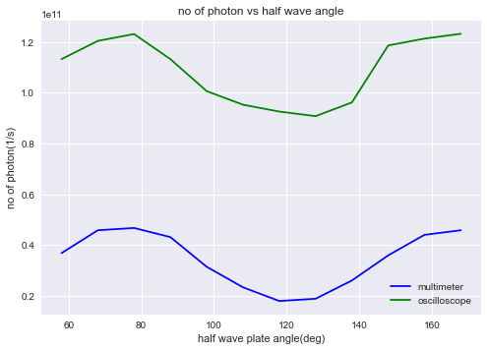

Figure 3: Plot of number of photons vs half wave plate angle for both multimeter and oscilloscope.

**Conclusion**

Three data sets were able to be obtained for twelve different half wave plate angles. Each of the data sets consists of the photodetector values and number of photons generated per seconds. From the first table of data sets where the output of the photodetector is connected to the multimeter, it can be seen that the output values are over the maximum signal of 12V without any significant changes for each increment of the half wave plate angle even with two filters screwed on. The lowest value that was obtained with each adjustment of the orientation of the half wave plate was (12.26±0.005)V at 208º while the highest value recorded was (12.30±0.005)V at 258º, 268º and 278º respectively. It is also shown that the photodetector value was increasing slowly but gradually decreases from 278º. Step size of 10º was chosen to be taken as each voltage reading only increases by 0.01V. Any step size lower or higher than 10º would generate too much of a difference between each voltage reading and would ultimately yield a constant value. This would not have given us the sufficient amount of data to analyse. Therefore, step size of 10º was chosen to be reasonable.

In regards to table 2, the second set of data with the oscilloscope fluctuates with each orientation to the half wave plate angle. It can be seen that the half wave plate angle started at an angle of 308º which then increased until 358º but decreased all the way down towards 8º. The reason being is because the lowest value observed on the oscilloscope was (10.1±0.05)mV at an angle that is close to 360º that is 308º. The photodetector values kept a steady increase in the first six angles but fluctuates when dropped to 8º onwards. From figure 2, it can be seen that the graph produced did not yield a steady curve. On the other hand, when both the oscilloscope and multimeter are connected together from data set 3, it is observed that the multimeter reading reduces from volt to milli volt. As can be seen from figure 3, the values obtained and plotting are much more fitting compared to data set 1 and data set 2.

In conclusion, a better estimate of the plot and data sets would have been generated if more values were taken. However, due to the fact that the photodetector signal was saturating whereby the output values does not change with the orientation of the half wave plate, it imposed a limitation to the experiment performed.

**Reference**

Anonymous,(2017), *DET36A Si Biased Detector User Guide,* <https://wiki.nikhef.nl/gravwav/images/a/a9/DET36A-Manual.pdf>

Meadowlark Optic, Inc,(2005), *Basic Polarization Techniques and Devices,* [*https://www.meadowlark.com/store/applicationNotes/Basic%20Polarization%20Techniques%20and%20Devices.pdf*](https://www.meadowlark.com/store/applicationNotes/Basic%20Polarization%20Techniques%20and%20Devices.pdf)